Statistics Lecture 6.4: Sampling Distributions Statistics. Using Samples to Approx. Populations

Idea: use a sample to estimate a population.

How many samples of a size of “n” are possible out of a population of size “N”?

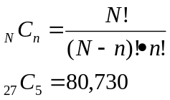

Sampling distribution of (Statistic) such as mean, proportion, Standard deviation, etc

Assume you are take all the possible samples of size “n” and find the required statistic for each sample.
If you organize all of those statistics of each different sample into a table, then this is a sampling distribution.

Example:
Only three numbers in the world and they are 1,2,5
what is the proportion of odd numbers? Answer = 2/3.
population proportion P=2/3
Sample proportion 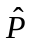 P-hat

Take all possible samples of size n=2
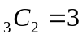
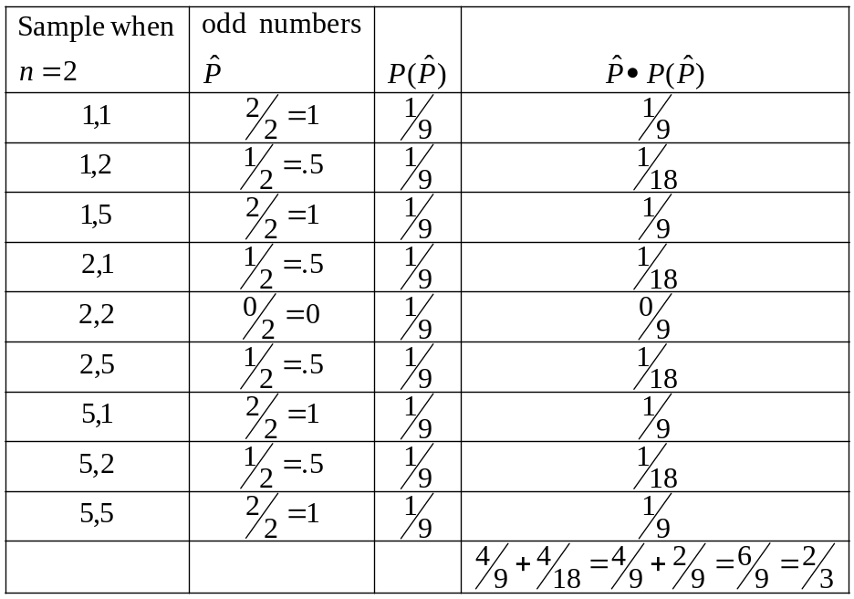

Sample proportions targets (estimates) population proportions.

Sample Distribution of the Mean
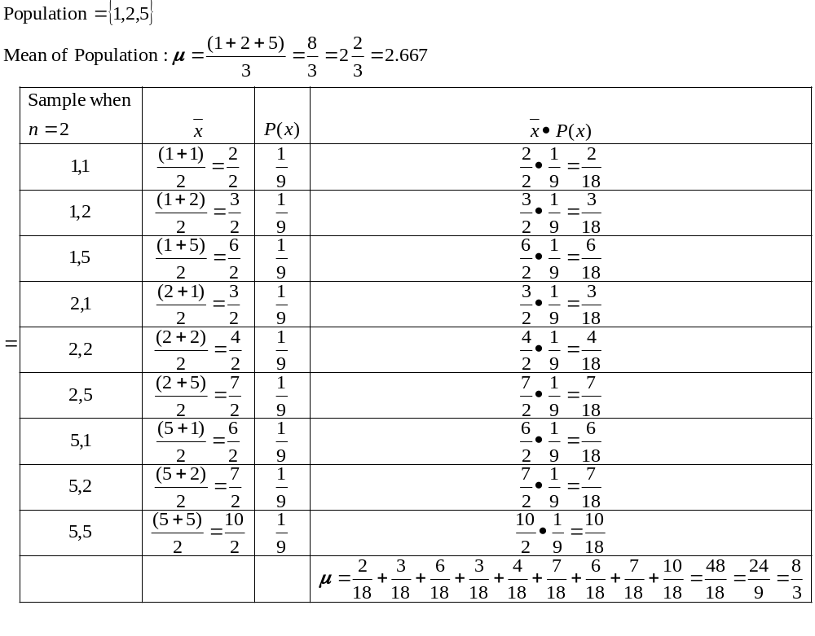

Sampling Mean is a good estimate of Population mean.

